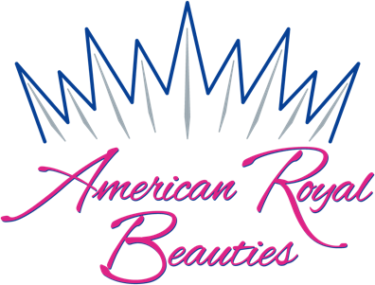
National
Interview Resume

Greetings Delegates,

Following this letter you will find your Interview Resume Form. It’s very simple to fill out; there are no “trick” questions and there are no right or wrong answers. Your resume is all about you. Just answer truthfully - it’s that easy!

Please note that the resume is only one sheet. Do not exceed one sheet, your resume is only an outline of your activities and should not include details. Many of you will have more information than you can fit on the page, in these cases, please do your best to condense your activities to fit the space provided. We have attached an example of a properly prepared resume to use as your guide.

Your resume will be used as a starting point for conversation during your interview. Think of your interview as if you were applying for the job of Queen, ultimately the judges will want to know why you want the position of American Royal Beauties National Queen. Again, there is no right or wrong answer, just be honest!

A well-prepared resume will be typed and utilize correct grammar, spelling and mechanics. Please print 4 copies of your resume to turn in at registration.

See attached sample.

I believe in you! Just be yourself and you will do just fine.

Good Luck Delegates!

Susan West
Executive Director

Basic Information

Name: Age: Division:

Awards and Honors

Community Service

Pageant Experience

Platform

Hobbies and Interests

Basic Information “SAMPLE”

Name: Susie Smith Age: 12 Division: Pre-Teen

Awards and Honors

2011 - 2014 Honor Roll
2013 Academic Excellence Award
2012 & 2013 State Speech Winner
2012 Governor’s Gold Achievement Award

Community Service

2011 – 2015 Served by providing entertainment for various local nursing homes
2011 – 2014 Participated in local city beautification project
2012 – 2013 Worked with local church youth group to provide school supplies
2011 – 2013 Worked with my local Girl Scout troop collecting supplies for soldiers

Pageant Experience

This is my first pageant. I am hopeful that I will have the opportunity to proudly represent this organization.

Platform

I do not have a specific platform at this time. In the future I hope to develop my platform based on helping patients in the Pediatric Cancer Ward at Children’s Hospital.

Hobbies and Interests
I enjoy singing, composing my own music, playing guitar, and competition tennis.

